**PARKING MANAGEMENT SYSTEM**

**Project Report INT-213**

***by***

**Abhishek Singh, Ifshita Kumari, Ajay Sharma**

Section: K19PG

Roll Numbers: 39,51,53



**Department of Intelligent Systems,**

**School of Computer Science Engineering,**

**Lovely Professional University, Jalandhar**

November, 2020

**Student Declaration**

This is to declare that this report has been written by me/us. No part of the report is copied from other sources. All information included from other sources have been duly acknowledged. I/We aver that if any part of the report is found to be copied, I/we are shall take full responsibility for it.

Signatures:

Name: Abhishek Kumar,ifshita Kumari,Ajay Sharma

Roll Number: 39,51,53

Place: Online Submission using GitHub and UMS

Date: 31-10-20

GitHub link-

<https://github.com/abhishek-singh77/K19PG-G-4>

**TABLE OF CONTENTS**

**1. Bonafide and Introduction of the project**

|  |  |  |
| --- | --- | --- |
| **2. Background and objectives of project assigned** | |  |
| **1.1** **Background** | |  |
| **1.2 Objective** | |  |
| **1.3 Outcome** | |  |
|  | |  |
|  |
| **3 Description of Project** | |  |
| **2.1. code description** | |  |
| **2.3. Explanation**  **4 Conclusion with SWOT analysis.** | |  |

**BONAFIDE CERTIFICATE**

Certified that this project report “Parking Management System” is the Bonafede work of “Abhishek Singh, Ajay Sharma, Ifshita Kumari” who carried out the project work under my supervision.

Dr. Dhanpratap Singh

Associate Professor,

ID- 25706

Department: Intelligence System

LPU, Phagwara

**INTRODUCTION**

**INTRODUCTION**

Parking management systems for managing the records of the incoming and outgoing vehicles in a parking house.

It’s an easy for Admin to retrieve the data if the vehicles have been visited through number, he can get that data.

Now days in many public places such as malls, multiplex system, hospitals ,offices market areas there is crucial problem of vehicle parking .The vehicle parking has many lanes/slots for car parking .so to park a vehicle one has to look for all the lanes .Moreover this involves a lot of manual labor and investment .Instead of vehicle caught in towing the vehicle can park on safe and security with low cost .

Parking control system has been generated in such a way that it is filled with many secure devices such as, parking control gates, toll gates, time and attendance machine, car counting system etc. These features are hereby very necessary nowadays to secure your car and also to evaluate the fee structure for every vehicle’s entry and exit.

The objective of this project is to build a parking management system that enables the time management and control of vehicles using number plate recognition .The system that will track the entry and exit of cars ,maintain a listing of cars within the parking lot ,and determine if the parking lot is full or not .It will determine the cost of per vehicle according to their time consumption .

**MAIN REPORT**

**Background and Objectives of the project**

This is GUI based application designed using Tkinter, for managing a complete parking system from user and admin Database to vehicle parking slots.

**OBJECTIVE OF THIS PROJECT**

The main objective of project on parking management system is to manage the details of Parking slots, vehicle details and customer phone number. It manages all the information about parking Fees, Vehicle. Customers, Parking slots. The Project is built at administrative and thus only the Vehicles details, Parking slots. It tracks all the details about the Parking slots (free an occupied both), vehicle number, customers number.

**Outcome of the project are as follow:**

* Provide the park in facility with the location of slot reserved for the vehicle.
* After the parking the Admin will be informed
* Admin can monitor the empty and occupied slots
* After the check out the Admin will be informed
* If checkout is done when slots are empty Data is shown
* During registration Data is saved in database for security

**Description of Project**

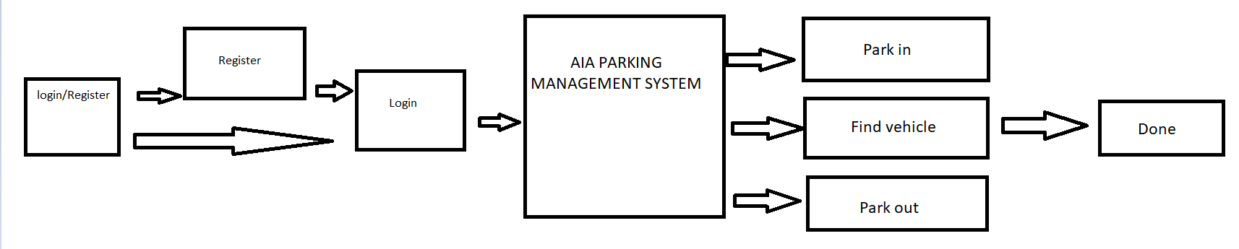

First window comes with login and register options when the system is initiated.

If already an Admin login directly otherwise need to register first and then login.

After the successful login main window opens where parking tasks are preventive.

AIA Parking management system.

Parking management system comes with 3 options.

1. Park in
2. Find vehicle
3. Park out

Park in – used to book a slot for vehicle

Find vehicle – used for getting information about all slots (both free and in use)

Park out – used to remove the vehicle and free the slot

Finally, information is saved and system is closed.

**Work Division /Roles among Students**

Abhishek Singh:

Coordinator of project

Back – end; Major Part of Database design and code. Creating the CSV file and window

displaying grids with red grid as occupied slot, yellow grid as empty, grey as road,

and blue telling the parking counter. Testing

Ajay Sharma:

Front – end: Major Part of AIA main interface using tkinter, applying buttons and labels

as per the UI design and applying the color scheme accordingly. Selection of font style

and size. Providing cross queries for database. Testing

Ifshita Kumari:

Major Part of UI designing, choosing the dimension and color scheme to be applied

Creating the registration window and the pop-ups at registration and login success.

Providing cross queries for database. Testing

We used team explorer feature of visual studio 2019 community and applied changes directly to each other’s code.

**Explanation of Project:**

First window –

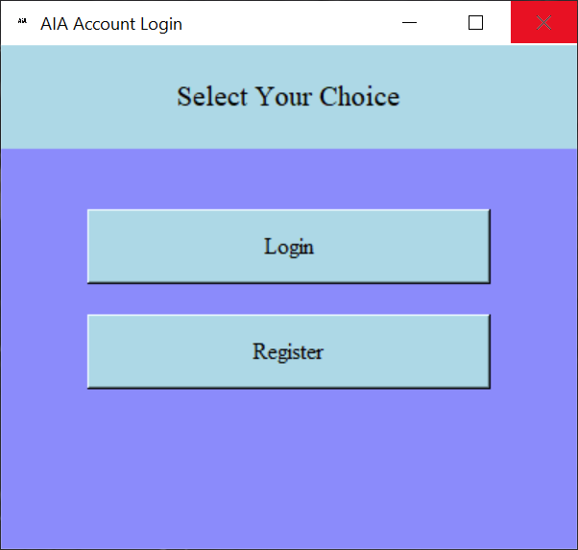

First window which came once the software is turned on.

It provides Admin to login or Register if already not register.

This interface has two buttons Login and Register with command to open new window

For opening user login and user registration.

It has one canvas and one frame and a top label containing “Select your choice” text.

The color scheme is unique and a proper UI designing has been done for such color combination.

Second window – (register)

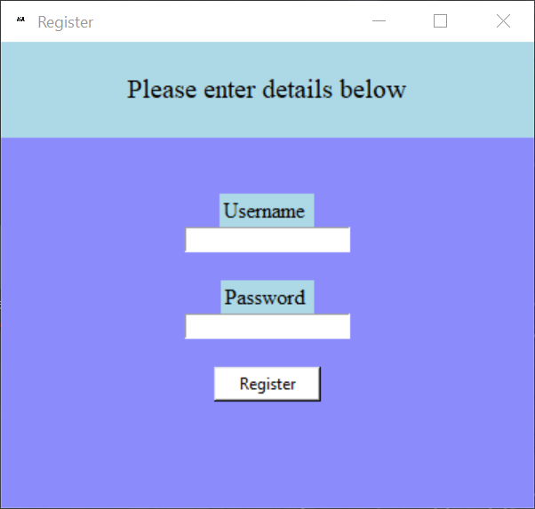

If the user is new, he/she need to register herself/himself in the database.

Once the register is complete one can use it for login.

Third window – (login)

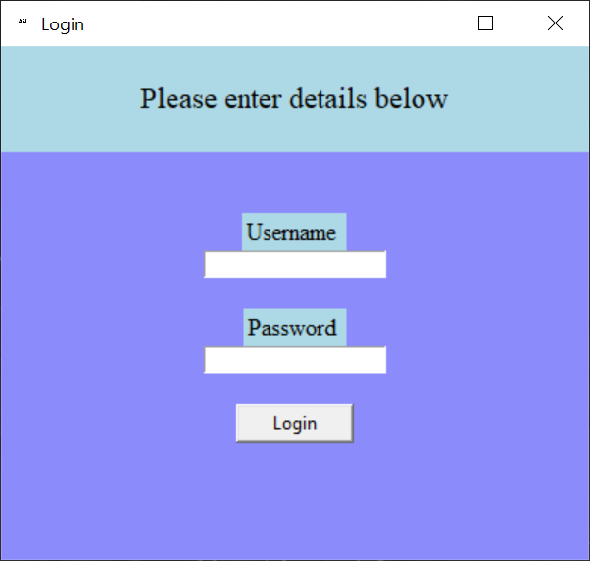

Admin can login to main page after filling the required details.

If not a user or a new one need to register first before login.

Fourth window – (main page)

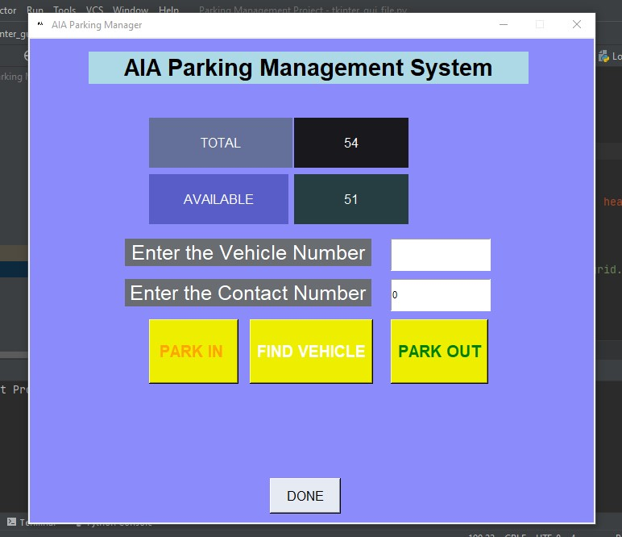

After the successful login main frame comes up.

Admin can perform various tasks here as shown in picture above.

Fifth window – (when vehicle is parked in)

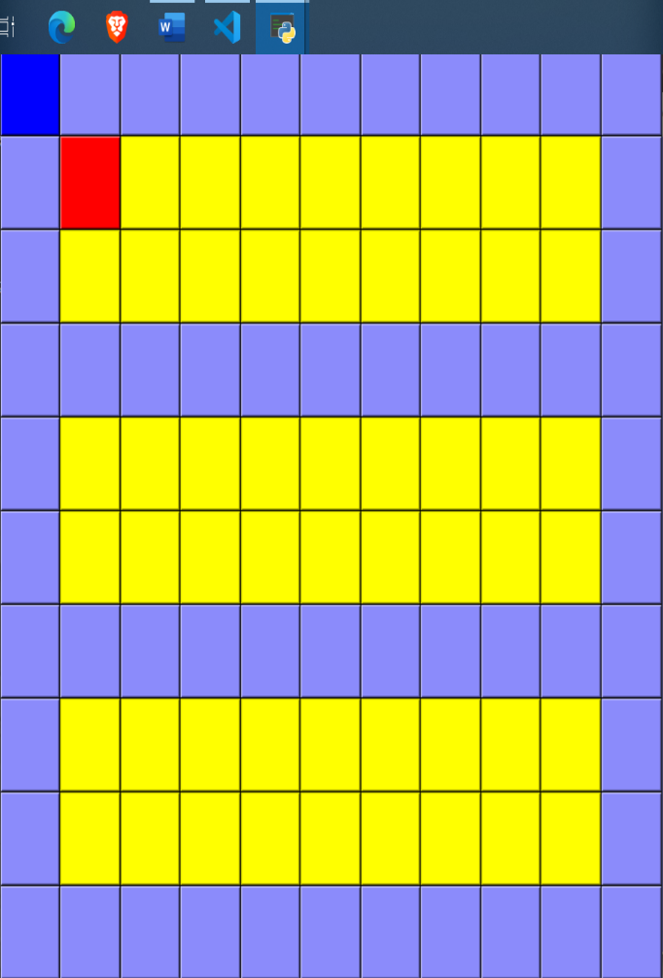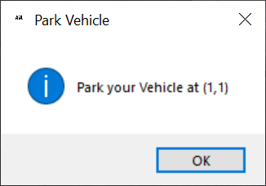

After filling the details of vehicle and customer phone number an empty slot is provided for the parking as shown in pictures. (picture one shows position in coordinate and picture two shows pictorial representation)

RED indicates the parked slots

YELLOW indicates the free slots

sixth window – (find a vehicle location)

***After entering the required details***

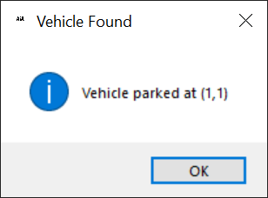

For finding the location of a vehicle, parking details are required and it will tell you the location/coordinate of the parking slot.

Seventh window – (when vehicle is parked out)

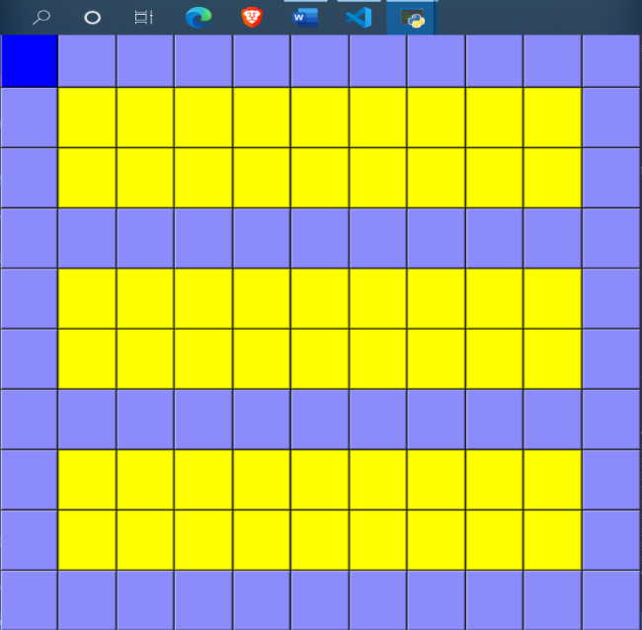

After the park out of the vehicle the color of slot changes from red to yellow.

The data is cleared from the data base.

Eighth window – (when the task is completed)

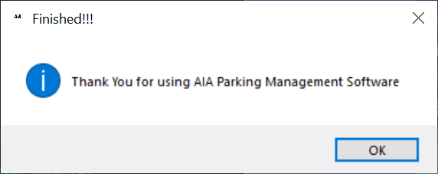

Final pop up when system is closed.

**Technology and Platform used:**

1. Python 3.8

* Pandas
* SQLite3
* Tkinter
* Datetime
* OS

1. Visual Studio 2019 community
2. GitHub
3. Windows 10
4. MS EXCLE

**CONCLUSION**

**SWOT Analysis**

**1.Strength**

* **After the use of software, the data is not lost**
* **User friendly interface as anyone can use**
* **Data of the user is safe and can’t be accessed by anyone else**
* **Same Data can’t be repeated if vehicle is already parked**

**2.Weekness**

* **Data lost once the vehicle is park out**
* **Only limited vehicle can be added**

**3.Opportunities**

* **Creating and charging parking issue at ease**
* **Hosting service dealing with proper parking at various places.**

**4.Threats**

* **Local server control requiring presence of extra person.**
* **Marketing of the service**
* **Managing Expenses**

**Future Plans**

**We are planning to host an online server through which we can manage complete database from a single server. This will help us to keep track of all the vehicles and the slots available. Also, it’ll help us to understand which places are more often occupied and which places are empty and through this data we can enhance our service with a larger extent.**